- GENERAL DATA & INFORMATION

Bay No. |  |  | Bay Name
Relay designation | LINE DIFF. |  | Model No. | 0411L1x6x1C7CCxH5C424xx
Make |  |  | S. No.
Rated Current | 1A |  | Rated Voltage | 66.4 V L-N AC
Frequency | 50/60 HZ
Logic inputs | 125VDC |  | Aux. Voltage | 125/250V AC/DC
Comm. Interface  CH-X | IEEEC37.94,  850nm Fiber |  | Comm. Interface  CH-Y | IEEEC37.94,  850nm Fiber

- MECHANICAL CHECKS AND VISUAL INSPECTION

Sl.no | General checks | Status
1. | Inspect for no physical damage.
2. | Verify the wiring connection as per approved drawing.
3. | Relay case connected to a local earth bar.
4. | Power up the relay circuit and check relay is healthy.
5. | Set the relay internal clock.
6. | Send the relay setting configuration file to relay through Port F.

WATCHDOG RELAY CHECK:

Check status of watchdog contacts as below.

OUTPUT | Contact Status |  | Remarks
 | Relay De- energized | Relay Energized
ALARM C28-C29 | CLOSE | OPEN

RELAY DC BURDEN CHECK:

Relay Status | V Aux Applied(V) | I Measured (mA) | Expected Watts | Calculated Watts
Enabled | 125 |  | <25W
Enabled & Trip | 125 |  | <25W

CONTROL INPUT CHECK:

This is to verify the healthiness of the DC control inputs.
Apply a rated voltage at each input and verify the status of the input at Front panel or 5025 HMI.

Note:
- Open 5025 HMI view after the relay is connected to PC.
- Open “Device Overview” page and observe the Inputs status.

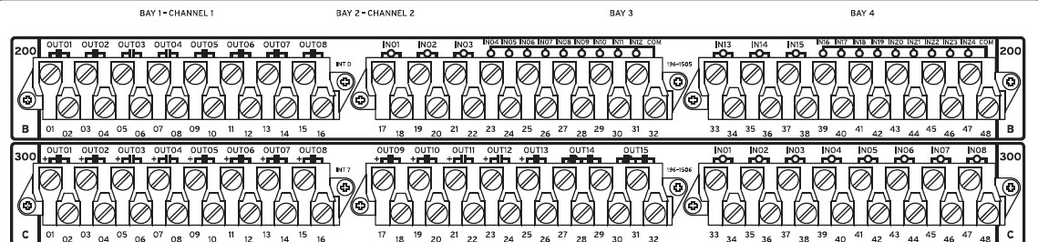

Control input No. | Configuration | Result
IN201
IN202
IN203
IN204
IN205
IN206
IN207
IN208
IN209
IN210
IN211
IN212
IN213
IN214
IN215
IN216
IN217
IN218
IN219
IN220
IN221
IN222
IN223
IN224
IN301
IN302
IN303
IN304
IN305
IN306
IN307
IN308

CONTROL OUTPUT RELAY CHECK:

This is to verify the healthiness of the Control output relay healthiness.
Operate each output through front panel or 5025 HMI, the check continuity of the contact that closes.

- For PULSE the relay outputs, “Breaker” jumper “JMP18-C” shall be put ON position. The jumper “JMP18-C” is available in main board, which is on the top. Open the relay front cover, and change the jumper to ON position on main board, as mentioned in instruction manual section2, page 852.
- Open 5025 HMI view after the relay is connected to PC.
- Open “Control Window” page and Select the OUTPUT that you want to PULSE and select the duration of the PULSE.
- Execute the PULSE command. Verify the physical contact close of the corresponding output.

Output Relay No. | Configuration | Result
OUT201
OUT202
OUT203
OUT204
OUT205
OUT206
OUT207
OUT208
OUT301
OUT302
OUT303
OUT304
OUT305
OUT306
OUT307
OUT308
OUT309
OUT310
OUT311
OUT312
OUT313
OUT314
OUT315

SINGLE END INJECTION (LOCAL):

The complete 87L relaying scheme requires pair of two relays one at each end for testing. The following tests in this section “SINGLE END INJECTION” are conducted with relay 87L channels are put in LOOPBACK Mode. These tests prove the relay healthiness, setting sensitivity, input and output configuration. However the complete relaying scheme shall be tested and recorded under section “END-TO-END” test.
NOTE:
- 87L function test requires, both local relay and remote relay connected with 87L communication interface and both are powered up. Also it requires current injection at local and remote end with time synchronized test operation.

- Single end current injection allows us to test only 87L sensitivity test. So, the sensitivity test only being performed and that is sufficient to verify the 87L setting.

CT/VT INPUT CHECK:

Note: This test is intended to verify the CT/VT inputs, measurement and CTR, VTR setting in the local relay.

Step1: Apply rated voltage and current to the relay CT/VT inputs.
Step2: Measure the current/voltage at relay HMI or from 5025HMI.

Note:
- Open 5025 HMI view after connecting to the relay.
- Click “Local Instantaneous metering” view and save the snapshot in to annexure word document.
- Click “phasor” view and save the snapshot in to annexure word document.

Find the “Report annexure section.2” for relay Measurement report.

Voltage Applied: 3PH, 115V AC Current applied: 3PH, 1.0A
PTR: 380KV/115V CTR: 3000/1A
CURRENT MEASUREMENT:
Local | PHASE A MAG/ ANG | PHASE B MAG/ ANG | PHASE C MAG/ ANG | 3I0  MAG/ ANG | 3I2  MAG/ ANG | I1  MAG/ ANG
Expected
Actual

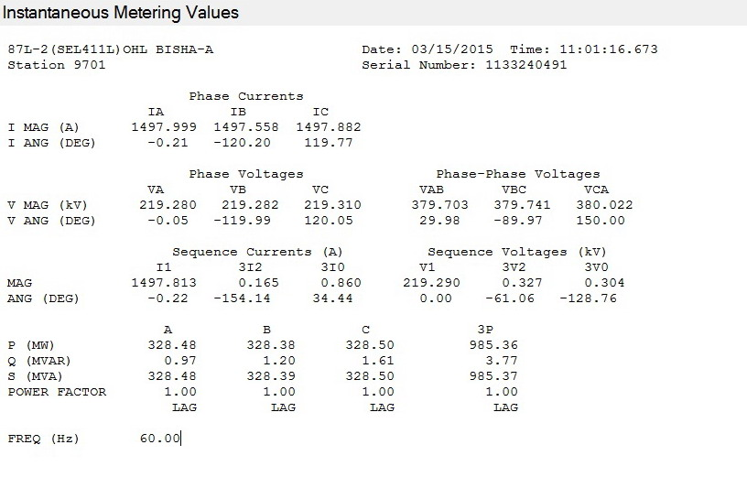

Local | PHASE A MAG/ ANG | PHASE B MAG/ ANG | PHASE C MAG/ ANG | 3I0  MAG/ ANG |  | 3I2  MAG/ ANG | I1  MAG/ ANG
Expected
Actual

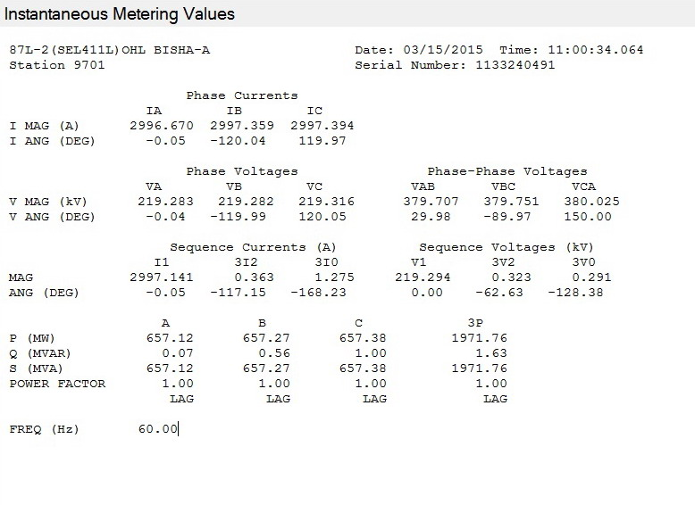

Local | PHASE A MAG/ ANG | PHASE B MAG/ ANG | PHASE C MAG/ ANG | 3I0  MAG/ ANG |  | 3I2  MAG/ ANG | I1  MAG/ ANG
Expected
Actual

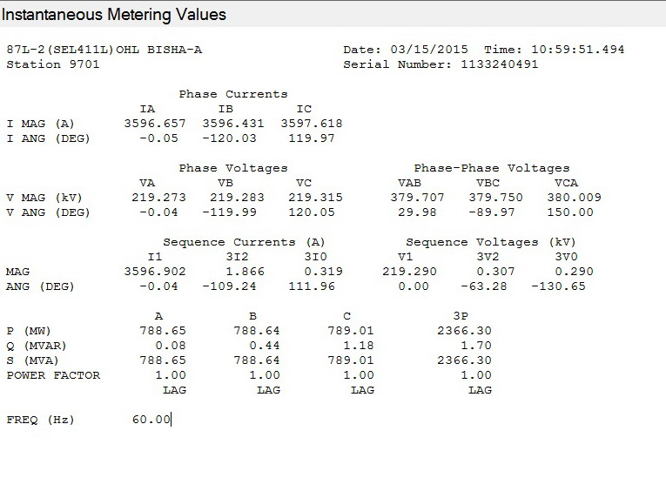

- VOLTAGE MEASUREMENT:

Local | PHASE AN MAG/ ANG | PHASE BN MAG/ ANG | PHASE CN MAG/ ANG
Expected
Actual

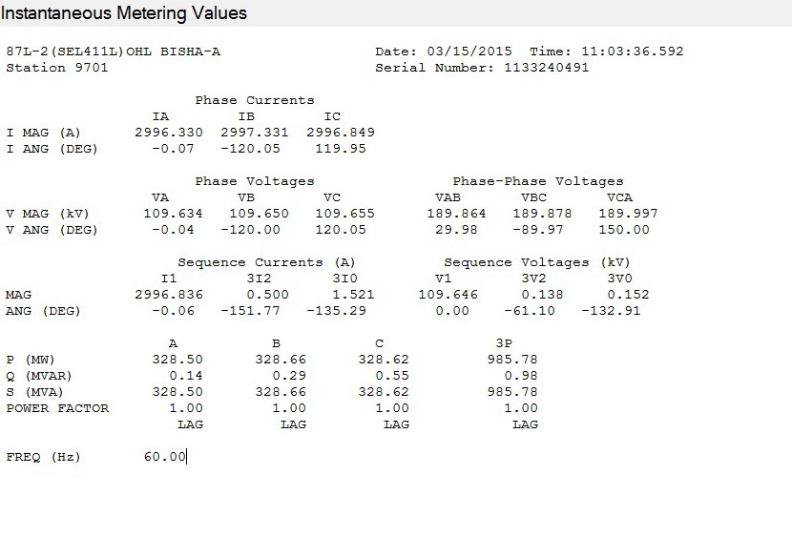

Local | PHASE AN MAG/ ANG | PHASE BN MAG/ ANG | PHASE CN MAG/ ANG
Expected
Actual

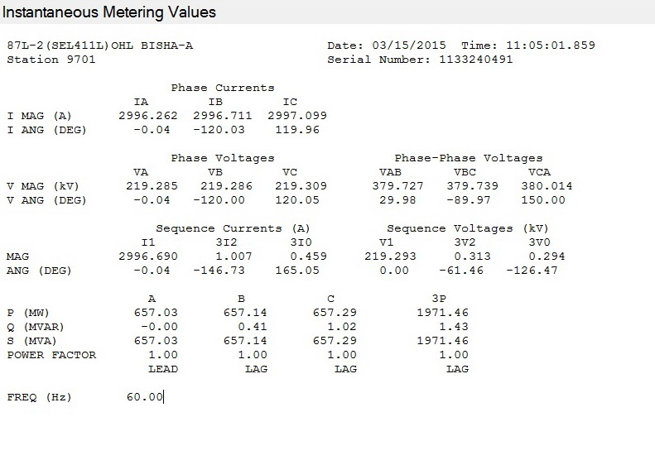

Local | PHASE AN MAG/ ANG | PHASE BN MAG/ ANG | PHASE CN MAG/ ANG
Expected
Actual

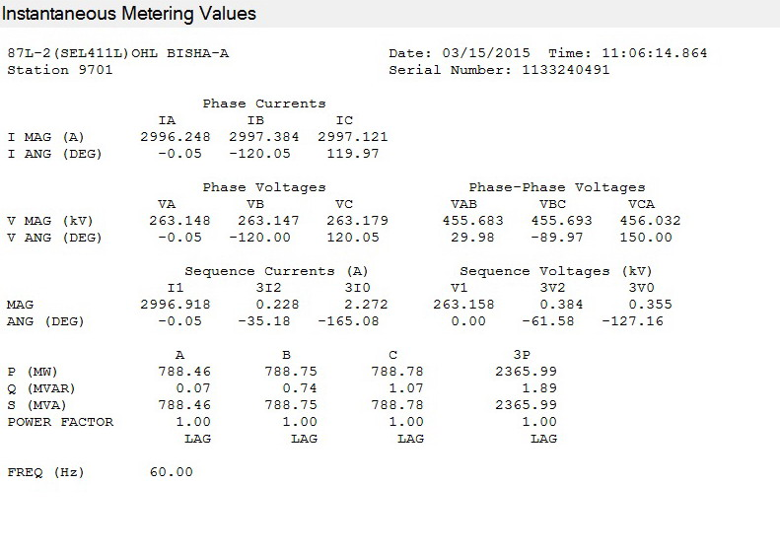

- POWER MEASUREMENT:

Current phase angle = -45deg
Local | MW | MVAR | PF
Expected
Actual

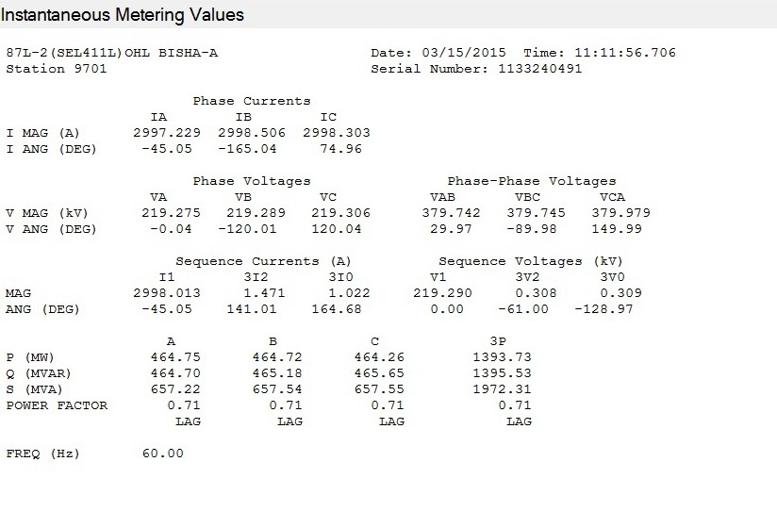

ACCURACY: according to the catalogue page 59

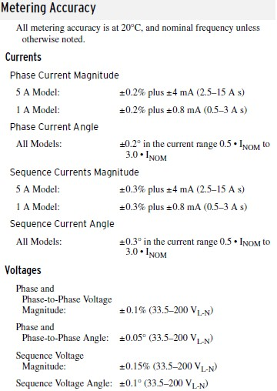

87L DIFFERENTIAL PROTECTION:

OPERATING PRINCIPLE:

The 87L protection function outputs trip when the following conditions (A & B) are met.
- The differential current (vector sum magnitude) is greater than minimum threshold (87LPP/ 87L2P/87LGP).
- The Alpha value is not in the Restraining Region on the alpha plane (OR) the Restraining criterion is disabled.
Note: The Restraining criterion is disabled until the relay finds more than 5%Inom both remote and local current.

MEASUREMENT OF CURRENT:

LOOPBACK TEST MODE:
The second option in the test mode is the loopback test. The 87L Test command can be used to facilitate loopback testing of communications channels to avoid the problem with a communications channel. When the loopback test is active, the relay substitutes the address of the remote relay with its own address in order to allow the 87L element to respond to the data transmitted by it.
To activate the Loop Back mode:
The comm. Channel 1 or2 shall be put LOOP BACK mode with following procedure.
- Connect PC to relay using 5030.
- Open “terminal “View”. Enter level 2.
- Type TEST 87L command as below to put CH1 or CH 2 in Test loopback.
- The fiber cable must be connected on the relay (between Tx to Rx) to the channel which we need to put in test loopback.
It isn’t allowed to put Ch 1 and Ch 2 in loopback in same time

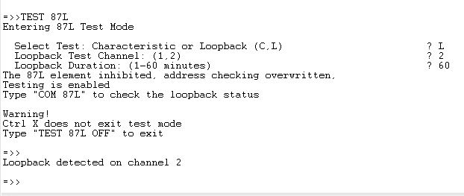

Current applied: 3PH, 1A
PTR: 380KV/115V CTR: 3000/1A
CURRENT MEASUREMENT WITH ONLY CH 1:
 | PHASE A MAG/ ANG | PHASE B MAG/ ANG | PHASE C MAG/ ANG | 3I0  MAG/ ANG |  | 3I2  MAG/ ANG | I1  MAG/ ANG
LOCAL | 0.998<-0.01 | 0.998<-120 | 0.999<120 |  | 0.001<157.9 | 0.001<-137 | 0.999<0
CHANNEL 1 | 0.998<-0.02 | 0.998<-120 | 1<119.94 |  | 0.003<109 | 0.002<-134 | 0.998<-0.04
Differential | 1.998<-0.02 | 1.998<-120 | 1.998<119.9 |  | - | - | -
Alpha | 1<180 | 1<180 | 1<180 |  | - | - | -

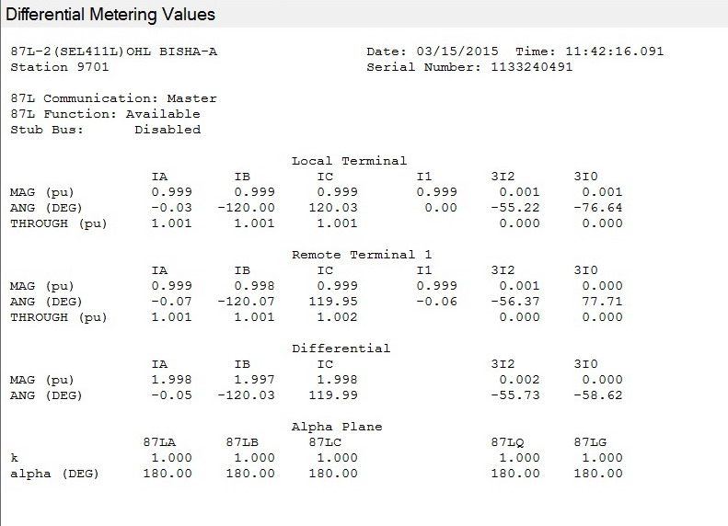

Current applied: 3PH, 1A
PTR: 380KV/115V CTR: 3000/1A
CURRENT MEASUREMENT WITH ONLY CH 2:
 | PHASE A MAG/ ANG | PHASE B MAG/ ANG | PHASE C MAG/ ANG | 3I0  MAG/ ANG |  | 3I2  MAG/ ANG | I1  MAG/ ANG
LOCAL | 0.998<-0.01 | 0.997<-120. | 0.997<120 |  | 0<-73.58 | 0.002<-1.46 | 0.998<0
CHANNEL 2 | 0.998<0.01 | 0.998<-120 | 0.997<120 |  | 0.001<178.2 | 0.001<30.89 | 0.998<0
Differential | 1.996<0 | 1.998<-120 | 1.998<120 |  | - | - | -
Alpha | 1<180 | 1<180 | 1<180 |  | - | - | -

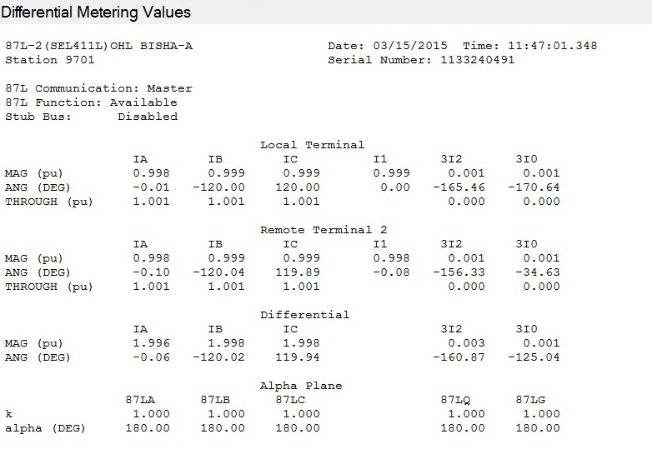

ALPHA VALUE:
Alpha is complex ratio between Remote current (IR) and local current (IL). It is represented with magnitude and angle.

I.1. sensitivity and TIMING TEST: ( ONLY WITH CH-X)

Note:
- The sensitivity and timing tests are conducted with relay to relay.
- In LOOP BACK test the local current is routed as remote current. So, the relay would see differential current twice the injected local current and the Alpha Value would be always 1<0deg , which is ideal operating point in operating region of Alpha plane. So, the expected pickup current is 50% of the 87LPP/ 87L2P / 87LGP.

- SENSITIVITY TEST:

Step1: Set ‘EOCTL’ =N, EDD=N, to avoid blocking of 87L2,87LG and blocking due to slow change in current.
Step2: Set 87L2P=OFF and 87LGP =OFF, while testing 87LP, Do the same while testing others.
Step3: Increase current on one phase until relay trips on 87. Repeat the same for other phases.
Step4: The appropriate Relay Word Bit shall be monitored on front panel or 5025 HMI.

1. Use the TEST 87L command to enter Test Mode
2. Ensure that relay outputs are supervised or isolated. See Test Precautions for details.
3. When prompted, select a characteristic test and single-terminal mode. Choose the element and normal or secure depending on the particular settings to be tested.

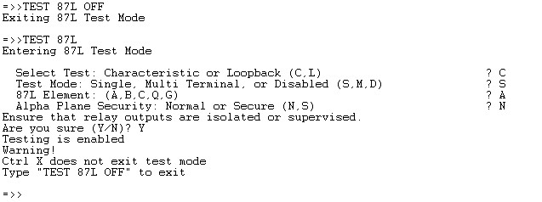

PHASE CURRENT DIFFFERENTIAL:
87LPP | Expected pick up  87LPP | Phase A |  |  | Phase B |  |  | Phase C
 |  | P/U  (A) | HMI display Idiff = IAT  (secA) | D/O (A) | P/U (A) | HMI display Idiff = IBT  (sec A) | D/O (A) | P/U  (A) | HMI display Idiff = ICT  (sec A) | D/O (A)
Pick up Accuracy: ±3% ±0.01 INOM, According to the Catalogue for manual # 20130311 Page 56

87LPP | Expected pick up  87LPP | Phase A |  |  | Phase B |  |  | Phase C
 |  | P/U  (A) | HMI display Idiff = IAT  (secA) | D/O (A) | P/U (A) | HMI display Idiff = IBT  (sec A) | D/O (A) | P/U  (A) | HMI display Idiff = ICT  (sec A) | D/O (A)

NEGATIVE/ ZERO SEQ CURRENT DIFFERENTIAL:
87L2P/ 87LGP | Expected pick up  87L2P or 87LGP | 87L2 –Negative seq diff |  |  | 87LG- zero seq diff
 |  | P/U (A) | HMI display Idiff= 3I2T  (pri A) | D/O (A) | P/U (A) | HMI display Idiff= 3I0T  (Pri A) | D/O (A)

Note:
For 87L2 /87LG sensitivity a single phase current shall be injected. In this case the negative sequence (I2) or zero sequence (I0) current is equal to 1/3* Iph. But the relay compares 3 x I2_injected and 3 x I0_injected with the 87L2P / 87LGP thresholds.

TIMING TEST:

SETTING:
87LPP: A 87L2P: A 87LGP: A

PHASE | Inject current | Delay time | Operating time at  2x87LPP (msec)
A
B
C

ALPHA PLANE RESTRAIN TEST:

Note:
This test requires simultaneous current inject from time synchronized test kits, if the injection shall be performed at different location of local and remote relay.

ALPHA ANGLE TEST:
SETTING:
87LPP: 1.0A 87L2P: 0.1A 87LGP: 0.1A 87LR:2TST 87LANG:195 DEG
- Enable 87LPP and disable 87L2P and 87LGP for testing 87LP.
- Apply Phase A, local current and remote current as IR= 1A<0deg, IL=1A<0deg. With this current the relay would be operate region.
- Vary the phase angle of IR and note down relay operate region and restrain region.
- The same shall be done for other phases.

Diff. element | IL angle (fixed) | IR angle at Relay operates | IR angle at Relay resets
87LA | 0
87LB | 240
87LC | 120
87L2 | 0
87LG | 0

Accuracy: +/- 3° of angle setting, According to the Catalogue for manual Page 56

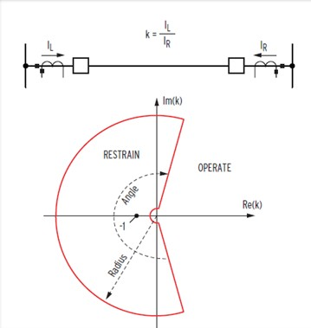

Expected Restraining angle:

Alpha angle = 180deg to 180-(87LANG/2)
Setting 87LANG=195deg,
Restraining angle = 180 to 82.5 deg, Operating angle = 82.5deg to 0deg
Accuracy: +/- 3deg .

ALPHA RADIUS TEST:

SETTING:
87LPP: 0.2 A 87L2P: 0.1A 87LGP: 0.1A 87LR:2 87LANG:195 DEG

- Apply local and remote current out of phase and equal magnitude.
- Increase the remote current magnitude by fixing local current until the relay trip to find the outer radius
- Increase the local current magnitude by fixing remote current until the relay trip to find the outer radius.

ALPHA RADIUS MEASURED AT ALPHA ANGLE =180deg.

Diff. element | RADIUS ODPERATION |  |  | RADIUS OPERATION
 | I Local (fixed)A | I Remote(A) | Radius(IL/IR) | I Remote (fixed) A | I Local (A) | Radius (IL/IR)
 |  | Operate |  |  | Operate
87LA
87LB
87LC
87L2
87LG

Expected outer radius: 2
Accuracy: +/-5% setting as per instruction manual page 58.

