Note:
- The approved updated final settings should be applied and printed out from the relay by using the software of the relay.
- The approved final setting and the printout final setting should be attached with this test format.
- The print out final setting should be signed by SEC AND Contractor.
- The following test format contains minimum required tests and some of settings are mentioned as an example and not as limitation.

- GENERAL DATA & INFORMATION

Panel No. |  | C.T Ratio
Relay Type |  | Rated Current. :
Manufacturer |  | No. of contacts:
Serial No |  | DC. Auxiliary. Voltage
Order - No. |  | Frequency F_{n} | 60 Hz

- MECHANICAL CHECKS AND VISUAL INSPECTION

As per TCS –P–105 Rev -1, Item no 4.1& 4.12.1.1

item | Description | Remarks
1 | Inspect for any physical damage or defects. | Yes | N/A
2 | Verify connections and ferrules as per approved drawings | Yes | N/A
3 | Check tightness of all the connections. | Yes | N/A
4 | Check Apparatus List | Yes | N/A
5 | Check relay version and switching elements on printed circuit board | Yes | N/A

- ELECTRICAL TESTS: AS PER TCS –P–105 REV -1, ITEM NO 4.2& 4.12.1.2

  - FUNCTION TEST

Item | Description | Remarks
 | Human Machine Interface (HMI) Checked. | Yes | N/A
 | Case Earthing checked. | Yes | N/A
 | LED’s Function Checked. | Yes | N/A
 | Trip Contacts Checked. | Yes | N/A
 | Reset Function Checked | Yes | N/A
 | Group active Functions Checked | Yes | N/A
 | Binary inputs checked. | Yes | N/A
 | Output Relays Checked | Yes | N/A
 | Event Display on HMI Screen Checked | Yes | N/A
 | Test switch / plug checked for correct function. | Yes | N/A
 | Watchdog contacts checked | Yes | N/A
 | Current shorting facility. | Yes | N/A

  - RELAY BURDEN

ITEM | DESCRIPTION | DC Voltage (V) | Current (mA) | Watts
1 | Normal Condition | 125
2 | Fault Condition | 125

Limits: according to the Catalogue for Technical Data – P54X/en TD/ Ja4 Page: 32
Minimum 11W or 24VA

SUPPLY Off
TERMINALS (CLOSED) - (J11, J12) :
TERMINALS (OPEN) - (J13, J14) :

SUPPLY ON
TERMINALS (CLOSED) - (J13, J14) :
tERMINALS (OPEN) - (J11, J12) :

  - CURRENT TRANSFORMER SHORTING TERMINALS:-

Current Input | Terminals | Shorting Checked
I R | C3 – C2 – C1
I B | C6 – C5 – C4
I Y | C9 – C8 – C7
I N | C15 – C14 – C13 | *
I M | C12 – C11 – C10 | *
* Not be checked because it is not used in the scheme.
This table according to the Catalogue for Commissioning and Maintenance – P54x/EN CM/G53 – Page No; 11

  - TIME AND DATE CHECK: -

If the time and date is not being maintained by an irig-b signal, so in the event of the auxiliary supply failing, with a battery fitted in the relay, the time and date will be maintained.

To test this, remove the auxiliary supply from the relay for approximately 30 seconds, on restoring the auxiliary supply the time and date should be correct.
Result: ____________

  - MEASUREMENTS: -

- For Angle Measurement; Set Measurement Ref is VR. '' See; Catalogue: Application Notes – P54X/ EN AP/ H53 – Page No; 110''
- Inject three phase current with different values and angles.
- For Neutral Current (N) Inject 3 Phase Current with same magnitude and same phase angles.
So, IN = IR + IB + IY = 3 X I inject.

PHASE | APPLIED CURRENT |  | DISPLAY VALUE |  | %ERROR
 | Magnitude | Angle | Magnitude | Angle | Magnitude | Angle
R
Y
B
N

Limits: Amplitude Accuracy; ± 1 %
Phase Accuracy ; ± 2º
According to the Catalogue for Technical Data – P546/en TD/ H53 – Page: 24

  - PICK UP & DROP OFF TEST FOR DIFFERENTIAL CURRENT (ID)

    - Select test loop back external from HMI.

    - Arrange fiber optic connection as show.
T

CH 1

R

P543
T

CH 2

R
R 3
4
P591
7
8
T
F. O
F. O
R 3
4
P591
7
8
T
F. O
F. O

    - Calculate the expected op. value from the formula below (when external loop back is selected.

NOTE: Dual Redundant Must be selected at P546.
P591: FIBER OPTIC CONVERTER.
Pick up Value = 0.5 x (I_{s1} + K1 x I _{bias}) A
Where; K1 = 30 % = 0.3 P.U
Drop Out Value = 0.75 x (Pick Up Value) A

PHASE | SETTING  Is1 (A) | Injected Current  I bias A | Expected Pick Up Value (A) | Measured Pick Up Value (A) | Measured Drop Out Value (A)
R | 0.4 | 0 | 0.2
Y | 0.4 | 0 | 0.2
B | 0.4 | 0 | 0.2
R-Y | 0.4 | 0 | 0.2
Y-B | 0.4 | 0 | 0.2
B-R | 0.4 | 0 | 0.2
R-Y-B | 0.4 | 0 | 0.2

Limits: Pick up & Drop Out ±10%

According to the Catalogue for Technical Data P546/en TD/ H53 Page: 10

  - OPERATING TIME TEST FOR DIFFERENTIAL CURRENT (ID):

Set; DT Mode & Is1 = 1 In & K1 = 30 % & Is2 = 20 In & K2 = 150 %

PHASE | Inject current (A) | Delay Time setting (ms) | Meas. Time (ms)
R | 4 | Zero (Inst)
 | 4 | 100
 | 4 | 200
Y | 4 | Zero (Inst)
 | 4 | 100
 | 4 | 200
B | 4 | Zero (Inst)
 | 4 | 100
 | 4 | 200
R-Y | 4 | Zero (Inst)
Y-B | 4 | Zero (Inst)
B-R | 4 | Zero (Inst)
R-Y-B | 4 | Zero (Inst)

Accuracy:
Instantaneous Operation: <30 ms.
Definite Time Operation: ± 2 % or 20 ms whichever is greater.
Phase Time Delay Range: 0.0 Sec. To 100 Sec.
According to the Catalogue for Technical Data – P546/en TD/ H53 Page: 10
.
  - INVERSE OPERATING TIME TEST FOR DIFFERENTIAL CURRENT (ID)

Set; Is1 = 1 In & K1 = 30 % & Is2 = 20 In & K2 = 150 % & Iinj = 1 A

Characteristic | Operating time at twice current setting and time multiplier/  Characteristic time dial setting of 1.0
 | Meas. Time (ms) | Nominal (seconds) | Range (seconds)
 | R PHASE
IEC SI |  | 10.03 | 9.53 - 10.53
IEC VI |  | 13.50 | 12.83 - 14.18
IEC E |  | 26.67 | 24.67 - 28.67

According to the Catalogue for commissioning – P546/en cm/ ka4 – Page: CM (10-55)

  - BIAS CHARACTERISTIC TESTING

To avoid absence of fiber optic communication then blocking of differential protection element;
At Commission Tests menu, Set '' Test Loop back '' is '' external ''. Through HMI only.

    - Lower Slope

Connect the test circuit as shown figure.

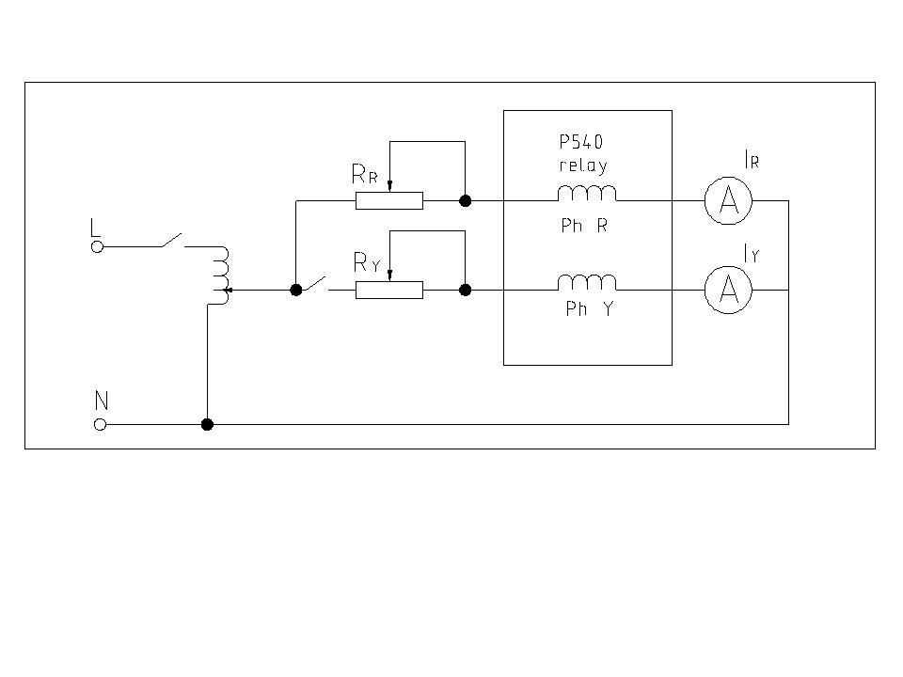

A current is injected into the R phase which is used as the bias current and another current is injected into the Y phase which is used as differential current.

Inject a bias current of 1A in the R phase. The relay will trip and any contacts associated with the R phase will operate.

Slowly increase the current in the Y phase until phase Y trips. Record the phase Y current magnitude and check that it corresponds to the following equation;

I_{d Calculated} = 0.5 * (I_{s1} +I _{bias} K₁) A
Where: IS1 is The Basic Diff Current Setting.
K₁ is the Lower Percentage Bias Setting.
Set; I_{S2} = 2 In

To check more than one point at the same slope, Change the bias current value and the equation above can be used, and also for other differential settings '' Different slopes, Is1 ''.
Apply the above procedure for each phase.

K1 | I_{S1} | I bias A | Id calculated | Id Measured |  |  | Errors %
 |  |  |  | R | Y | B | R | Y | B
30% |  | 0.1
 |  | 0.4
 |  | 0.5
 |  | 1.0
 |  | 1.5
40% |  | 0.1
 |  | 0.4
 |  | 0.5
 |  | 1.0
 |  | 1.5
50% |  | 0.1
 |  | 0.4
 |  | 0.5
 |  | 1.0
 |  | 1.5

Limits; ± 10 % According to the Catalogue for Commissioning and Maintenance – P54x/EN CM/G53 – Pages No; 30 & 31

    - Upper Slope

Repeat the test and check the result with the following equation;
I_{d Calculated} = 0.5 X [(I bias X K2) – {(K2 – K1) X I_{S2}} + I_{S1}] A
I_{s2}; the Bias Current Threshold Setting.
K₂; the High Percentage Bias Setting.
I_{S1} & K1 are Fixed; I_{S1} = 0.4 A, K1 = 40 %

K2 | Is2 | I bias A | Id calculated | Id Measured |  |  | Errors %
 |  |  |  | R | Y | B | R | Y | B
110% |  | 2.0
 |  | 3.0
 |  | 4.0
120% |  | 2.0
 |  | 3.0
 |  | 4.0
150% |  | 2.0
 |  | 3.0
 |  | 4.0

Limits; ± 10 % According to the Catalogue for Commissioning and Maintenance – P54x/EN CM/G53 – Pages No; 30 & 31

