Note:
- The approved updated final settings should be applied and printed out from the relay by using the software of the relay.
- The approved final setting and the printout final setting should be attached with this test format.
- The print out final setting should be signed by SEC AND Contractor.
- The following test format contains minimum required tests and some of settings are mentioned as an example and not as limitation.

- GENERAL DATA & INFORMATION

Panel No. |  | CT Ratio : ______
Relay Type |  | In
Manufacturer |  | VT Ratio
SERIAL NO |  | Vn
No. of contacts: |  | Draw. & Sh No. :
Order - No. |  | Conn.Diag.No.
Software Version |  | DC. Auxiliary. Voltage
Opto-coupler supply: |  | Frequency F_{n} | 60 Hz

- MECHANICAL CHECKS AND VISUAL INSPECTION

As per TCS –P–105 Rev -1, Item no 4.1& 4.12.1.1

item | Description | Remarks
 | Inspect for any physical damage or defects. | Yes | N/A
 | Verify connections and ferrules as per approved drawings | Yes | N/A
 | Check tightness of all the connections. | Yes | N/A
 | Check Apparatus List | Yes | N/A
 | Check relay version and switching elements on printed circuit board | Yes | N/A

- ELECTRICAL TESTS

As per TCS –P–105 Rev -1, Item no 4.2& 4.12.1.2

  - FUNCTION TEST

Item | Description | Remarks
 | Human Machine Interface (HMI) Checked. | Yes | N/A
 | Case Earthing checked. | Yes | N/A
 | LED’s Function Checked. | Yes | N/A
 | Trip Contacts Checked. | Yes | N/A
 | Reset Function Checked | Yes | N/A
 | Group active Functions Checked | Yes | N/A
 | Binary inputs checked. | Yes | N/A
 | Output Relays Checked | Yes | N/A
 | Event Display on HMI Screen Checked | Yes | N/A
 | Test switch / plug checked for correct function. | Yes | N/A
 | Watchdog contacts checked | Yes | N/A
 | Current shorting facility. | Yes | N/A

  - OPERATING DC SUPPLY CURRENT:

DC voltage (V) | DC current w/o fault (mA) | DC current with fault (mA) | Max. calculated watt (W)

Limit: DC burden Watt. (Refer to the reference technical manual page ).

    - Watch Dog Check

SUPPLY OFF
TERMINALS (CLOSED): (X11:2, X11:3) :
TERMINALS (OPEN): (X11:1, X11:3) :
SUPPLY ON
TERMINALS (CLOSED): (X11:1, X11:3) :
TERMINALS (OPEN): (X11:2, X11:3) :

    - Time and Date Check

To check time & date go to main menu on the display for REL670 then open system time and adjust time & date.
To test keeping time and date setting this, remove the auxiliary supply from the relay for approximately seconds, then restoring the auxiliary supply, the time and date setting should not be lost.
Result: ____________

  - Setting Adopted

Refer enclosed setting printout

  - Secondary Injection Tests

    - Distance Protection:

- Zones Reach measurements

Item | Description | Checked
1 | Testing results should be Printed by the Freja (tester) software.

PH-E (PE): -Resistive reach:
RFn (Ω/loop) = RFn (Ω/loop) * Mf
Reactive reach:
Xn (Ω/loop) = Xn (Ω/phase) + XNn(Ω/phase)
XNn = KNx* Xn (Ω/phase), KNx= 1/ 3 ((X0 – X1)/ X1)
S0: Xn (Ω/loop) = 1/ 3 {(2 * Xn (Ω/phase) + X0n (Ω/phase)}*Mf.
PH-PH (PP&3PH): -Resistive reach:
RFn (Ω/phase) = 1/ 2 RFn (Ω/loop) * Mf.
Reactive reach:
Xn (Ω/phase) = Xn (Ω/phase) * Mf.
RFn: Zone n resistive reach resistance.
Xn: zone n positive sequence reactance.
XNn: zone n earth returns reactance.
KNx: reactive compensation factor.
X0n: zone n zero sequence reactance, X0: line zero sequence reactance, X1: line positive sequence reactance.
Mf:CTR/VTR.

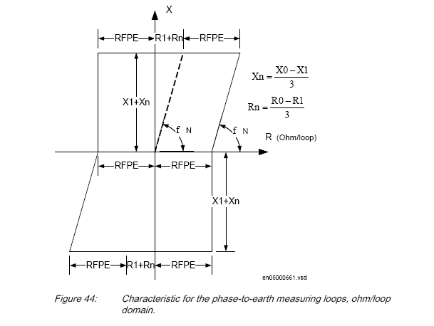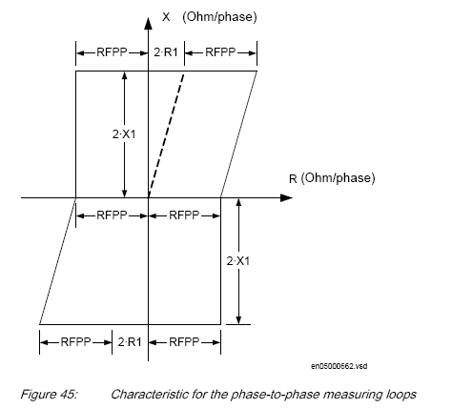

- Zone Timing Test:

Item | Description | Checked
1 | Testing results should be Printed by the Freja (tester) software.

Limit: 24 ms typically ± 10ms ± 0.5 % (REFERRING TO PAGE NO. )

    - Phase Selection Function (PHS)

- PHS Reach measurements

Item | Description | Checked
1 | Testing results should be Printed by the Freja (tester) software.

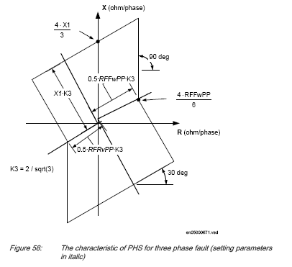
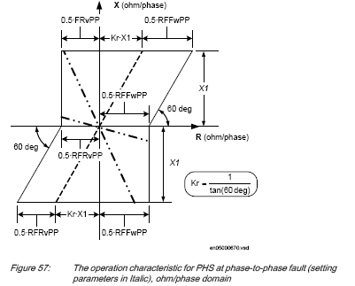

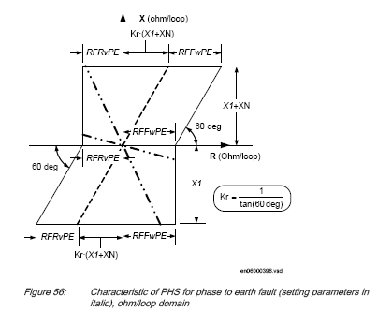

PH-E (PE):

- Resistive reach:

RLdfwphs (Ω/loop) = RLdfwphs(Ω/loop) * Mf.&RFrvphs (Ω/loop) = RFrvphs (Ω/loop) * Mf.

- Reactive reach:

X1phs (Ω/loop) = 1/ 3 {(2 * X1phs (Ω/phase) + X0phs (Ω/phase)} * Mf.

PH-PH (PP):

- Resistive reach:

RFphs (Ω/phase) = 1/ 2 RFphs (Ω/loop)*Mf.

- Reactive reach:

X1phs (Ω/phase) = X1phs (Ω/phase)*Mf.

3PH:

- Resistive reach:

RFphs (Ω/phase) = 0.666 RFphs (Ω/phase)*Mf

- Reactive reach:

X1phs (Ω/phase) = 1.333 * X1phs (Ω/phase)*Mf.

- PHS timing test:

Item | Description | Checked
1 | Testing results should be Printed by the Freja (tester) software.

Limit 24 ms typically ± 10ms ± 0.5 %.( REFERRING TO PAGE NO. )

    - Power Swing Detection (PSD)

- PSD Reach test Measurement:
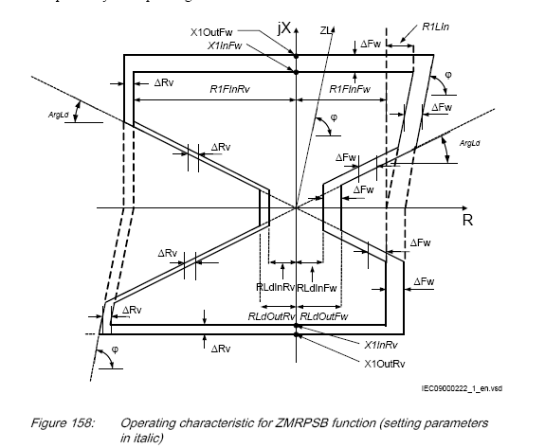

RLdInF_{w}=kLdRF_{w} * RLdOutF_{w}
RLdInRv = kLdRRv·RLdOutRv
The inner characteristic for the reactive reach in forward direction correspond to
the setting parameter X1InFw and the outer boundary is defined as X1InFw + DFw,
where:
DFw = RLdOutFw - KLdRFw · RLdOutFw
The inner characteristic for the reactive reach in reverse direction correspond to the
setting parameter X1InRv for the inner boundary and the outer boundary is defined
as X1InRv + DRv.
where:
DRv = RLdOutRv - KLdRRv · RLdOutRv

Item | Description | Checked
1 | Testing results should be Printed by the Freja (tester) software.

- Timing Test

    - Check the Operating Time (TP1)

TP1: it is the smallest time can be passing from outer boundary to inner boundary of Power Swing Chars. to detect PSD Start
-Freja general mode, sequence, 3 stages.
-1ST STAGE: Normal Load, 3phase Vr&Ir, outside the outer zone area
-2nd STAGE: 3phase V&I to get the impedance inside the PSD zone (I=Ir & V/I<Zouter and T =Tp1).
-3RD STAGE: 3phase V&I to get the impedance outside PSD zone and pass the inner boundary (I=Ir & V/I<Zinner and T =1 SEC).
Change 2nd stage timing till get PSD operating time exactly.

Type of fault | Tp1 setting ms | Tp1 actual ms
3 phase | 40

Limit: ± 10 ms (see the tech. ref. manual page).

    - Check the Blocking Time (tR2):

tR2: if the PSD is detect a 3Phase zone fault for time is longer than tR2, then it Block PSD function.
- FREJA GENERAL MODE
-1ST STAGE: 3PHASE healty V&I (I=Ir, V/I >outer zone setting impedance).
-2ND STAGE: 3PHASE V&I (I=Ir, V/I <inner zone setting impedance).
-3RD STAGE inside 3Ph fault for time >= tR2.
-change the time of 3rd stage till get trip, which mean blocking of PSD
The relay is tested on final setting

SETTING VALUE | MEASURED VALUE
2000 ms

Limit: ± 10 ms (see the tech. ref. manual page ).

Check of the blocking function

Item | Description | Checked
1 | Blocking of zone 1, 2, 3 & 5

Test procedure: same as before only change the time for 3rd stage to be less than 1 sec.

    - Check of the relay tripping during power swing if a single phase faults occurred, tR1 [ ]

tR1: if the PSD is detect a single phase fault, so after time equal to tR1, then it Block PSD function

- FREJA GENERAL MODE
-1ST STAGE: 3PHASE V&I (I=Ir, V/I > outer zone setting impedance).
-2ND STAGE: 3PHASE V&I (I=Ir, V/I < inner zone setting impedance).
-3RD STAGE outside PSD for time < tR2.
-4RD STAGE inside 1Ph fault for time >= tR1
-change the time of 4th stage till get trip, which mean blocking of PSD

SETTING VALUE | MEASURED VALUE

    - CHECK THE FAST PSD TIME (tP2)

tP2: it is second operating timer for PSD (Fast PSD), if PSD occur for second time at interval equal to Tw.
FREJA GENERAL MODE
-1ST STAGE: 3PHASE V&I (I=Ir, V/I >outer zone setting impedance).
-2ND STAGE: 3PHASE V&I (outer zone > I=Ir, V/I > inner zone setting impedance) for time >= tP1.
-3RD STAGE: 3PHASE V&I (I=Ir, V/I <inner zone setting impedance) for time = 100 ms.
-4th STAGE leave PSD and back to normal load for time < Tw.
-5th STAGE pass outer PSD for time >= tP2
-6th STAGE pass inner PSD
Note, you must minimize the TH, which is the holding time for PSD starting signal
-change the time of 4th stage and 5th stage to get Tw, tP2 timers

Timer | SETTING VALUE | MEASURED VALUE
Tw
tP2

    - Minimum operating Current test

For all zones
IBase= A UBase= V IMinOpPP= IMinOpPE=
IMinOpIN=
Phase | Setting | Z1 | Z2 | Z3 | Z4 | Z5 | PHS
R-N
Y-N
B-N
R-Y
Y-B
B-R

IB:base current
All three current limits IMinOpPE, IMinOpIN and IMinOpPP are automatically reduced to 75% of regular set values if the zone is set to operate in reverse direction, that is, OperationDir = Reverse.

    - Directional test

Line characteristic angle:
Relay directional angles: ArgDir (15) and ArgNegRes (115)
- forward direction; the operating chs Area from: to:
- reverse direction; the operating chs Area from: to:
- the non directional area from: to: and from to:

    - Scheme Communication Test

Scheme selected: Blocking scheme
Coordination time : ms.

- carrier receive + Zone 2 fault

Trip Time :

Indication :

- No carrier receive + Zone 2 fault
Trip Time :
Indication :

- No Carrier receive + Zone 2 fault + Com fail

Trip Time :
Indication :

- Zone 3 fault ( reverse direction)

Indication :
Carrier send time: ms.
Tsend min. : ms (100 ms setting
Limit: ± 10 ms for operating time (see the tech. ref. manual)

- Coordination time test:

Setting | Measured
50
70
100

    - Switch On To Fault

- Dead Line Detection Function 3Ф (DLD): (used for SOTF internal detection)

Setting |  | Measured Values
Uph<(V) | Iph<(A) | Uph<(V) | Iph<(A)

Limit :( ± 0.5 % of Ur) for Uph< and (± 1 % of Ir) for Iph< (see the tech. ref. manual page ).

- Automatic Switch on to Fault (SOTF)

Distance Protection |  | Indications
SOTF - ON | Trip Time (msec)
Internal SOTF with DLD on the 3 phase.
External SOTF with manual Close pulse.

Activate the DLD with the internal SOTF function.
Limit: (±0.5%± 10ms) for operating time (see the tech. ref. manual page ).

- Fuse failure supervision function (FUSE)

Setting |  | Measured Values
3U0> | 3I0< | Phase | 3U0>(V)op | 3U0>(V)reset | 3I0<(A) op | 3I0<(A) reset

Limit: ± 0.5 % of Ur for 3U0> and ± 1 % of Ir for 3I0 (see the tech. ref. manual page ).

General mode:
-1st stage: 3phase V&I healthy case.
- Decrease one phase voltage till the indication led fuse fail appears.
- Decrease the same phase current till the indication led fuse fail reset.

- Fuse failure operating time: m sec.

-1ST stage: 3phase V&I healthy case.
-2ND stage: put fuse fail condition (take contact fuse fail)

- Check the blocking of the relay when the general block functions

(VT MCB TRIP) is activated [ ]
Check the Blocking of Fuse Fail
Fuse Fail Latching Time:
Inject Fault before Latching ( )
Inject Fault after Latching ( )

    - Service Values for Measurements

PH voltage applied: V.
PH current applied: A.
Phase shift : degree.
Frequency : HZ.
CT ratio : A.
VT ratio : KV

Values | Sec. Values (KV) | Prim. Values (KV) | Values | Sec. Values | Prim. Values
U1 |  |  | I1
U2 |  |  | I2
U3 |  |  | I3
U4 | - |  | I4
U1 – U2 | - |  | P | -
U2 – U3 | - |  | Q | -
U3 – U1 | - |  | F | -

    - Fault Locator Function

Line Length: Line impedance PH-E: Ω
Line impedance PH-PH: Ω .

Fault Type | Fault Impedance (Ω) | Expected display (Km) | Actual display (Km)
A-N(25)%
B-N(50)%
C-N(100)%
A-B(25)%
B-C(50)%
C-A(75)%
A-B-C(100)%

    - Directional Earth Fault DEF

IN>Dir = %IB
Polarization = % UB
RCA: = degree
TIME = sec

- Checks the Operating Characteristic Angle

Injected voltage = V injected current = A
Set time setting = 0

Phase | Operating area angles (FORWAD) |  | Blocking area angles (REVERSE)
 | Expected | measured | Expected | measured
R
Y
B

- Polarizing voltage (3v0) pickup and drop off test

Injected current= A applied angle = degree (RCA angle)
Vn (3V0) setting | Vn (3V0) measured
 | Pick up | Drop off

- Pick up at various operating angles for aided DEF

RCA

OPERATING AREA

3I0 COS (φ-RCA)>= (IN>DIR)

Angle | Pick-up | Drop-off | SET TIME SEC | OP TIME | Expected Value(mA)
 | Value (mA) | Value (mA)
60 |  |  |  |  | 200/COS(60-60)=200
135 |  |  |  |  | 200/COS(135-60)=773
225
270
325
345 |  |  |  |  | 773

- Pick up at Various Operating Angles for Delayed DEF

Angle | Pick-up | Drop-off | SET TIME SEC | OP TIME | Expected Value(mA)
 | Value (mA) | Value (mA)
60 |  |  |  |  | 200
135 |  |  |  |  | 200
225 |  |  |  |  | 200
270 |  |  |  |  | 200
325 |  |  |  |  | 200
345 |  |  |  |  | 200

- DEF Scheme Communication Test:

Scheme selected: Blocking.
Coordination time : ms.

fault | direction | Communication status | Send/receive | Trip time | indication
EF | FORWARD | HEALTHY | RECEIVE
EF | FORWARD | HEALTHY | ----
EF | FORWARD | FAIL | ----
EF | REVERSE | HEALTHY | SEND

Coordination Time Testing
Setting | Measured
50
70
100

    - Non Directional Earth Fault

IN> = %IB
TIME = sec
Angle | Pick Up (mA) | Drop off (mA) | Set Time (Sec) | Measured Time

    - Delay Over Current

I1> = %IB
Characteristic = Normally Inverse
Time Multiplier = sec
PHASE | PICK UP (mA) | Drop off (mA )
R
Y
B

Operating Time Test
PHASE | Injected Current | CALCULATED TIME | MEASURED TIME
R | 2I1
 | 5I1
 | 10I1
Y | 2I1
 | 5I1
 | 10I1
B | 2I1
 | 5I1
 | 10I1

    - Breaker Failure

IP> = %IB T1 = msec T2 = msec
PHASE | Pick Up (mA) | Drop off (mA) | T1 | T2
R
Y
B

    - Disturbance recorder checked [ ].

    - Binary outputs checked [ ].

    - Binary inputs checked [ ].

